A Progress Report on

**Facial Recognition Attendance System**

*carried out as part of the course CSE CS3270 Submitted by*

Mayank Khare

209301260

*in partial fulfilment for the award of the degree*

*of*

**BACHELOR OF TECHNOLOGY**

In

**Computer Science & Engineering**



**Department of Computer Science & Engineering,**

**School of Computing and IT,**

**Manipal University Jaipur,**

**JAN-MAY 2023**

**Acknowledgement**

This project would not have been completed without the help, support, comments, advice, cooperation, and coordination of various people. However, it is impossible to thank everyone individually; I am hereby making a humble effort to thank some of them.

I acknowledge and express my deepest sense of gratitude to my supervisor, Dr. Yadvendra Pratap Singhfor his constant support, guidance, and continuous engagement. I highly appreciate his technical comments, suggestions, and criticism during the progress of this project “Facial Recognition Attendance System.”.

I owe my profound gratitude to Dr. Neha Chaudhary, Head, Department of CSE, for her valuable guidance and facilitating me during my work. I am also very grateful to all the faculty members and staff for their precious support and cooperation during the development of this project.

Finally, I extend my heartfelt appreciation to my classmates for their help and encouragement.

**Registration No. Student Name**

**209301260 Mayank Khare.**



**Department of Computer Science and Engineering**

**School of Computing & Information Technology**

Date: 19-04-23

**CERTIFICATE**

This is to certify that the project entitled “**Facial Recognition Attendance System.”**

is a bona fide work carried out as ***Minor Project Midterm Assessment (Course Code: CS3270)***  in partial fulfillment for the award of the degree of Bachelor of Technology in Computer Science and Engineering, under my guidance by ***Mayank Khare*** bearing registration number **209301260**, during the academic semester *VI of year 2022-23.*

Place: Manipal University Jaipur, Jaipur

Name of the project guide: Dr. Yadvendra Pratap Singh

Signature of the project guide: ______________________

**Abstract**

In terms of time and staff workload, traditional methods for documenting student attendance in a classroom, such as roll-call and sign-in sheets, have been shown to be inefficient. Furthermore, they are vulnerable to human mistakes and proxy attendance, both of which lead to inaccuracies in the data recorded. Research has been carried out to improve how we keep track of class attendance. Some of the recommended alternatives, however, are both pricey and impracticable. Most solutions also overlook the issue of proxy attendance. In this day of quickly growing new technologies, there is no reason why a critical educational practice like attendance should be considered in the traditional, monotonous way. It is challenging to manage big groups of students in a classroom using the traditional way. It is not advised since entering data into a system takes time and has a significant risk of error. Real-Time Face Recognition is a useful way of dealing with the daily attendance of a big number of students. Many algorithms like Haar Cascade Classifier for face detection and LBPH for face recognition have been used. The aim of this project is to automate the process of face recognition to the simplest level, so that it can be easily available for all kinds of security purposes and other identity recognizing units, with the use of similar languages and libraries. The complete process works on the parameters of training and detection of images and then recognizing it.

**Contents**

Page No.

Table of Contents (with page no’s)

1. Introduction 1
   1. Objective of the project
   2. Brief description of the project
   3. Technology used. 2
      1. H / W Requirement
      2. Software Requirement
   4. Organization Profile (if applicable)
2. Design Description 3
   1. Flow Chart
   2. Data Flow Diagrams(DFDs)
   3. Entity Relatoinship Diagram(E-R Diagram)
3. Project Description 6
   1. Data Base
   2. Table Description
   3. File/Database Design
4. Input/Output Form Design 7
5. Testing & Tools used (if applicable)
6. Implementation & Maintenance (if applicable) 8
7. Future scope 9
8. Conclusion 10
9. Bibliography 11

**1. Introduction**

**1.1 Objectives**

These are the objectives:

• To detect the face segment from the video frame.

• To extract the useful features from the face detected.

• To classify the features in order to recognize the face detected.

• To record the attendance of the identified student in excel sheet.

**1.2 Brief Description of the project**

Facial recognition attendance system is a biometric technology that uses artificial intelligence and computer vision to identify and verify individuals by analyzing their facial features. The system captures an image of the person's face and compares it to a pre-existing database of images to determine a match.

In the context of attendance tracking, the facial recognition attendance system can be used to automate the process of taking attendance in schools, universities, and workplaces. The system can be installed in various locations, such as entrances, classrooms, or offices, and can quickly identify and record the attendance of students or employees.

This system offers numerous benefits over traditional attendance tracking methods. It eliminates the need for manual tracking, which can be time-consuming, error-prone, and susceptible to fraud. Additionally, the system can provide real-time attendance tracking and reporting, allowing administrators to monitor attendance patterns and take action to address issues promptly.

Overall, facial recognition attendance systems offer a reliable, efficient, and secure way to manage attendance tracking in a variety of settings.

**1.3 Technology Used:**

**1.3.1 Hardware Requirements:**

* Camera: A high-resolution camera capable of capturing high-quality images is essential.
* Laptop or a computer with the following minimum requirements: -

**RAM –** 4 GBs or more.

**Storage –** 128 GBs or more.

**Processor –** i3 equivalent or better

.

**1.3.2 Software Requirements:**

* Integrated Development Environment (IDE): **Visual Studio Code**, for coding and debugging the software.
* Programming Language: **Python** to develop facial recognition software.
* Facial Recognition Library: A facial recognition library, **OpenCV**, to perform facial recognition tasks.
* Modules: **Dlib**(version 19.24 or higher), face-recognition(version 1.3.0 or above)
* Libraries – **numpy**(for mathematical tasks), **PIL** (Python Image Library for manipulating image files).
* Other Dependencies: **haarcascade_frontalface_default.xml** : OpenCV model to detect faces.
* Database Management System: A database management system to store attendance excel sheets data, such as Firebase.
* Operating System: A suitable operating system for the server and the computer used for software development.

**2. Design Description**

The following is the design description of the project: -

**2.1 Flowchart**

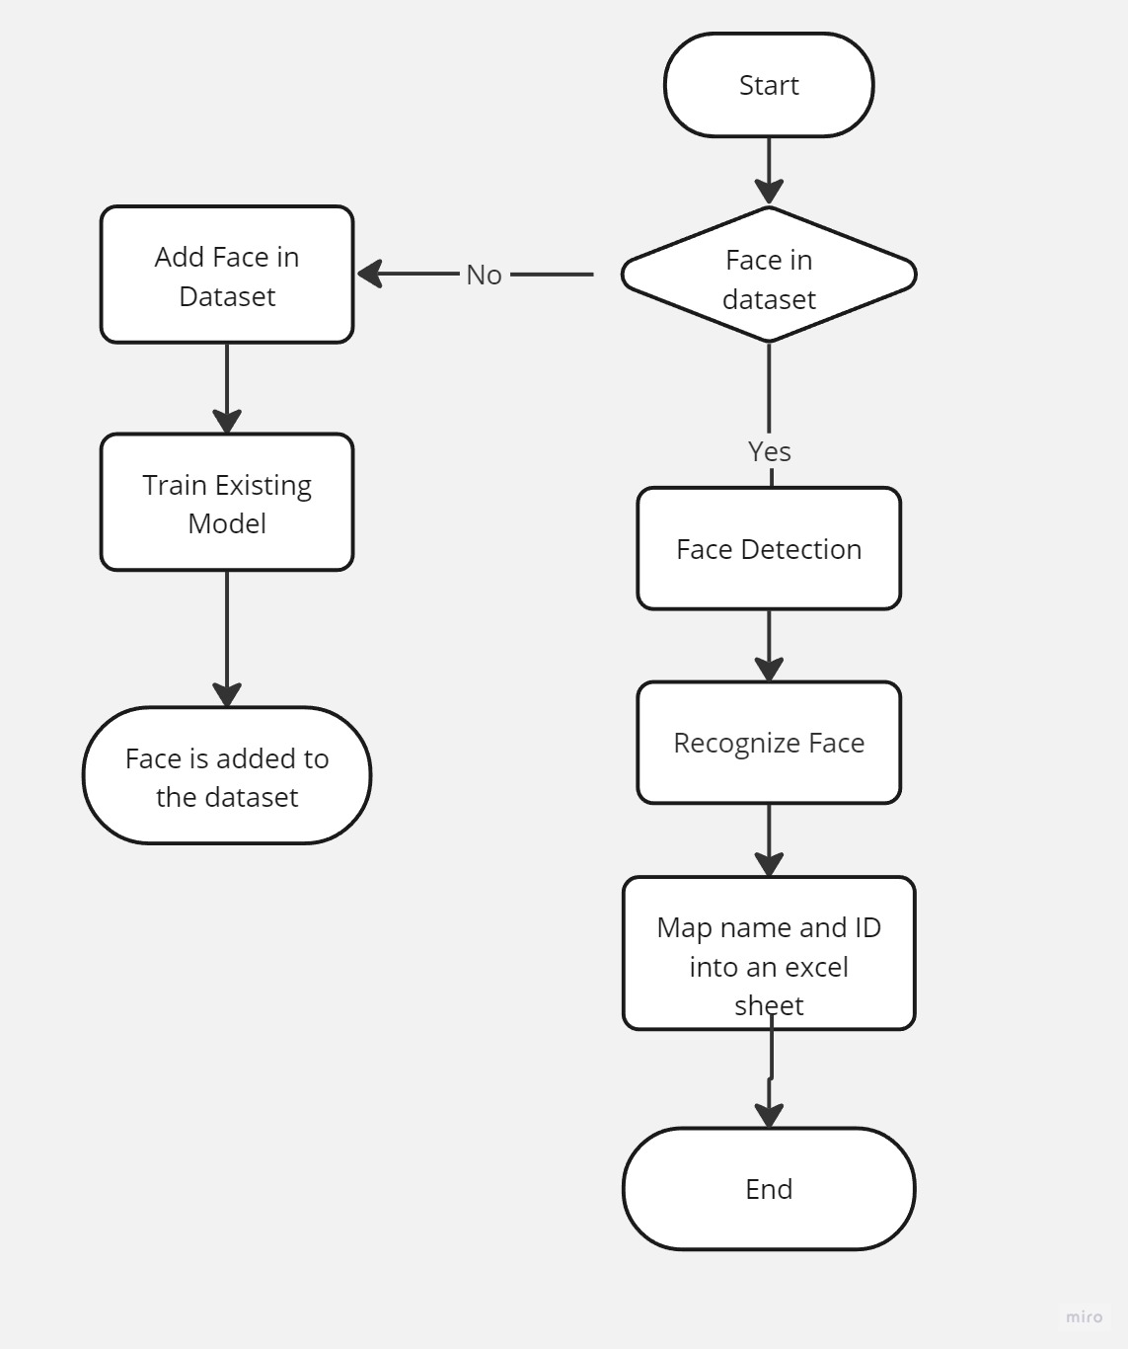

The above figure depicts the flow of the project.

**2.2 Data Flow Diagram**

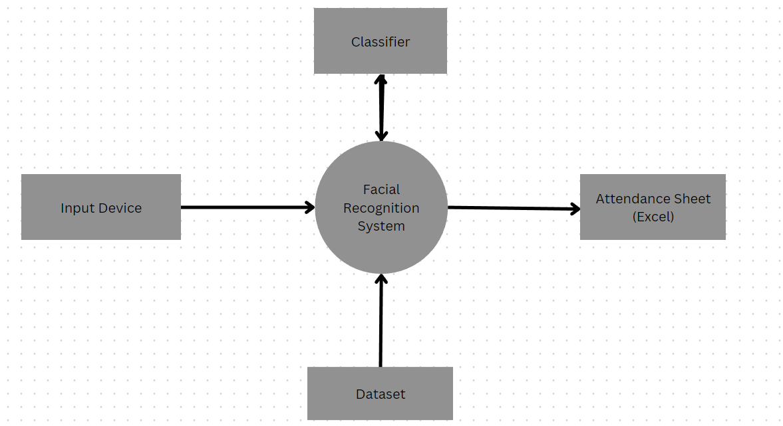

Level-0 DFD Diagram.

Level-1 DFD Diagram.

**2.3 Entity Relationship Diagram**

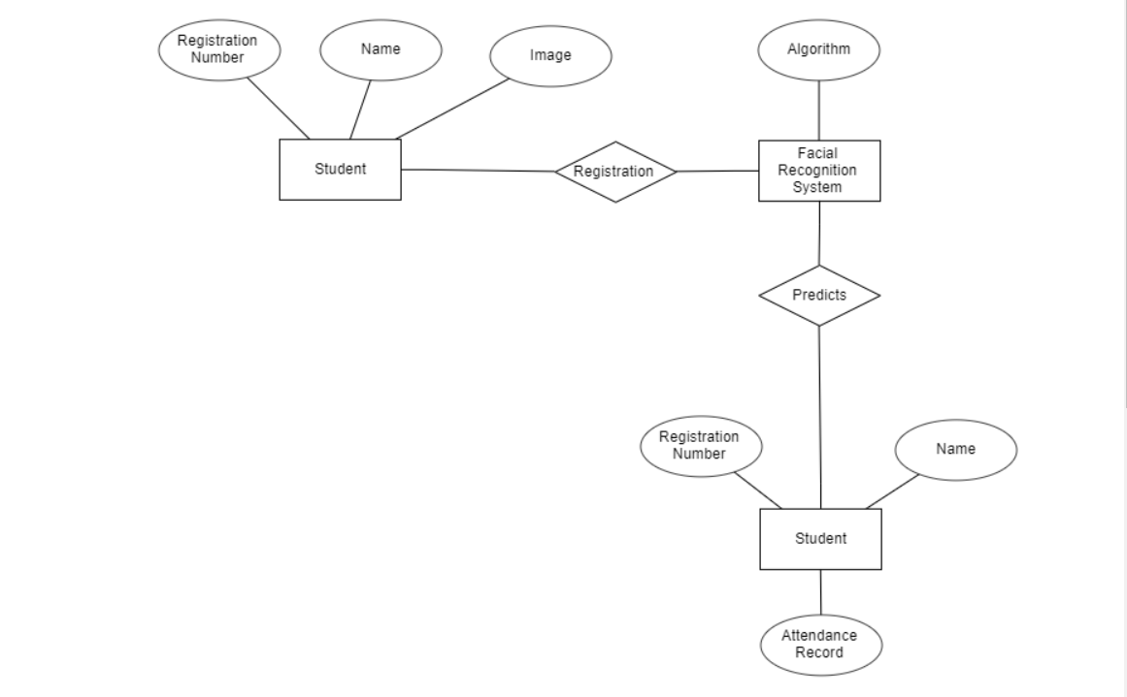 z The above figure represents an Entity-Relationship diagram.

**3. Project Description**

* 1. **Data Base**

The attendance record would be saved in an excel sheet, where one could find the necessary details like – name, registration number and time at which attendance was taken. These excel sheets would be saved bearing the date on which they were created.

These excel files could later be sorted and stored in any database, such as Firebase.

* 1. **Table Description**

Each table would consists of three attributes :-

1. Name
2. Registeration Number
3. Time

**3.3 File/Database Design**

The files would be in .xls (excel) format.

**3.4 Algorithms used.**

The entire process can be divided into 3 subparts: -

1. Dataset Collection – Any new addition to the dataset can be done simply by running the face_datasets.py file. Here, we will capture 100 photos of the student, convert it into grayscale (for haarcascade and LBPH algorithm) and then store it under an ID in a folder already created by the program, “training_data”.
2. Training the data – We will be using OpenCV’s pre-trained classifier to detect faces out of the training data. After that we will use LBPH(Local Binary Patterns Histogram), to analyze the faces of the dataset separately and independently.
3. Recognizing Faces - we characterize each image in the dataset locally; and when a new unknown image is provided, we perform the same analysis on it and compare the result to each of the images in the dataset. The way in which we analyze the images is by characterizing the local patterns in each location in the image.

**4. Input/Output Form Design**

The input would be in the form of a video stream, OpenCV would be used to capture video.

The frames of the video feed would be used to detect faces, extract their features and then recognize the face to mark the attendance.

The Attendance would be marked in an automatically generated excel file, which would contain the name, registration number and the time at which attendance would be marked.

**5. Implementation & Maintenance**

**Implementation** of a facial recognition attendance system involves several steps, including:

* Hardware installation:
* Software installation: The next step is to install the facial recognition software on the designated computers.
* Database creation: A database of authorized users' facial images needs to be created, along with any necessary metadata, such as employee names and IDs.
* System configuration: The system needs to be configured to recognize authorized users and record their attendance accurately.
* Testing and validation: Before the system goes live, it must be thoroughly tested to ensure that it works correctly and provides accurate attendance records.

**Maintenance** of a facial recognition attendance system is essential to ensure its continued reliable and accurate operation. Maintenance involves several tasks, including:

* User management: new students need to be added to the system, and existing students may need to be removed or updated as needed.
* System backups: Regular backups of the system data need to be taken to ensure that attendance records are not lost in case of system failure.

**6. Future scope**

The future scope of facial recognition attendance system is immense as technology continues to advance rapidly. Some potential areas for development and application include:

* Real-time tracking and monitoring: With the help of advanced computer vision and facial recognition algorithms, the system can provide real-time tracking and monitoring of individuals in various environments, such as workplaces and public spaces.
* Enhanced security features: The facial recognition attendance system can be enhanced with additional security features, such as liveness detection, to prevent spoofing and fraudulent attempts to bypass the system.
* Expansion of applications: The facial recognition attendance system can be expanded to various other applications, such as security and access control, retail and customer service, and healthcare.

**7. Conclusion**

Facial recognition attendance system is an innovative technology that has revolutionized the traditional attendance management system. With its advanced features and accuracy, it has become an ideal solution for organizations and educational institutions. It eliminates the need for manual attendance marking and reduces errors and frauds. Additionally, it helps in maintaining a record of attendance, which can be used for various purposes such as salary calculation, performance evaluation, and compliance purposes.

However, it is important to consider the ethical and privacy concerns associated with facial recognition technology. Organizations should ensure that the system is used transparently, and the data collected is used for the intended purposes only. Proper data security measures should also be taken to protect the sensitive information of employees or students.

Overall, facial recognition attendance system is a promising technology that has the potential to transform the way attendance management is done. With proper implementation and maintenance, it can bring numerous benefits to organizations and institutions while ensuring fairness and accuracy in attendance tracking.

**8. Bibliography/References**

Michael Dobson, Douglas Ahlers, Bernie DiDario, <Attendance Tracking System",

United States Patent Application Publication, Pub. No.: US 2006/0035205 A1, Feb.16,

2006.

Michael Dobson, Douglas Ahlers, Bernie DiDario, <Attendance Tracking System",

United States Patent Application Publication, Pub. No.: US 2006/0035205 A1, Feb.16,

2006.

[1] Yousuf, M., & Akbar, R. (2019). An efficient automated attendance system using facial recognition. International Journal of Computer Applications, 182(5), 24-30.

[2] Kang, J., Kim, S., & Cho, H. (2018). Facial recognition-based automatic attendance system using deep learning. Applied Sciences, 8(6), 905.

[3] C. N. Kumar Ravi, & A. Bindu, "An efficient skin illumination compensation model for efficient face detection," in IEEE Industrial Electronics, IECON 2006- 32nd Annual Conference, IEEE, Paris, France, 2006, pp. 3444-3449.

[4] Lin, C., Li, Z., Chen, L., & Zou, B. (2019). A novel face recognition-based automatic attendance system. In 2019 IEEE International Conference on Robotics and Biomimetics (ROBIO) (pp. 2242-2247). IEEE.

[5] Chen, Z., Wang, Y., Zhang, J., & Liu, X. (2020). Design and implementation of facial recognition-based student attendance management system. Journal of Physics: Conference Series, 1549(1), 012021.

[6] Raj, P. M., & Nair, N. B. (2019). Design of a facial recognition-based attendance system for academic institutions. In 2019 4th International Conference on Computing, Communication and Security (ICCCS) (pp. 1-6). IEEE.